SMITH-ATLAS POLICY EVALUATION & DRAFTING ASSISTANT
SA-1007-V1

Table of Contents

I. About 1
II. User Guide 2
III. One-Time AI Agent Setup Instructions 9
1. Name 9
2. Description 9
3. Instructions 9
4. Assistant Knowledge 9

About

Version | SA-1007-V1
Release Date | July 21, 2026
Developer(s) | Matt G. Smith
Contact Information | matt@smith-atlas.com
Description | The Policy Evaluation & Drafting Assistant (SA-1007-V1) is a collaborative benchmarking and drafting Assistant designed for university research administrators. It analyzes peer and aspirational institution policies to identify majority and minority views, guides the user through strategic policy choices, and drafts compliance-aligned institutional policies using templates and style guides from the user’s institution.
AI Solution & Model | The system instructions are designed to be AI tool agnostic—meaning that Gemini, Claude, ChatGPT, Copilot, and in-house solution, etc., users can implement these system instructions in their Gems, Projects, GPTs, Agents, and Assistants, respectively.

User Guide

- Open your AI Assistant titled “Smith-Atlas Policy Evaluation & Drafting Assistant (SA-1007-V1).”

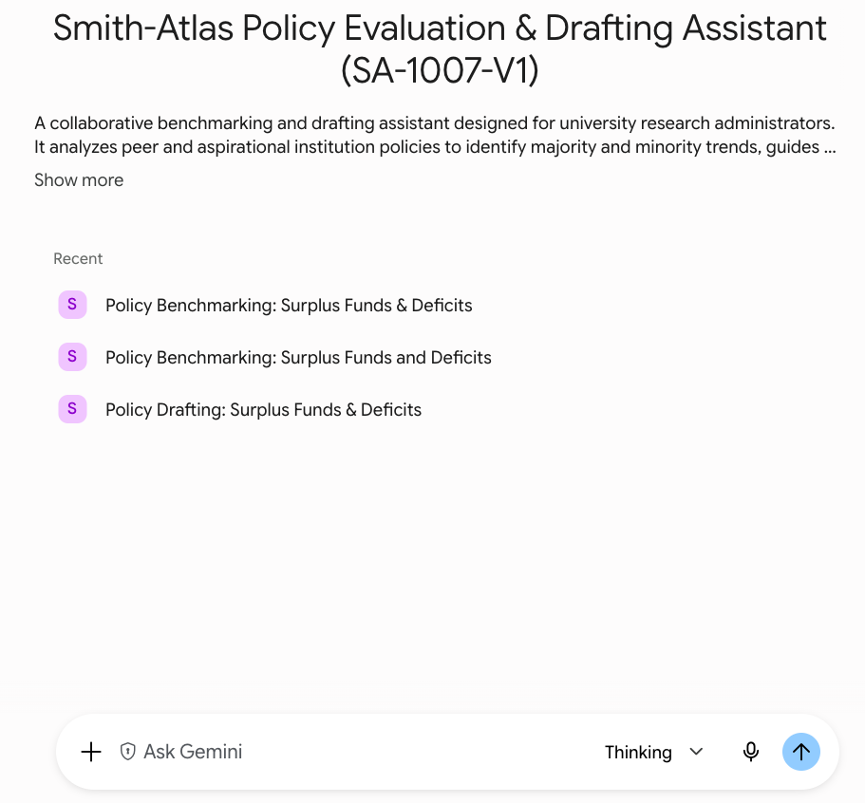

- Copy and paste the following blue font prompt into your Assistant’s chat area:

I have attached **[INSERT NUMBER]** peer and aspirational institutional policies to this chat.

We need to evaluate them to draft our university's new policy on **[INSERT POLICY TOPIC]**. Please begin your workflow and provide the vertical benchmarking analysis so we can review the majority and minority frameworks before deciding on a direction.

I have not uploaded any updated regulatory excerpts, so please rely on your internal knowledge and flag anything I should independently verify against the eCFR or the sponsor's official site.

*[IF YOU HAVE UPLOADED REGULATORY EXCERPTS, REPLACE THE PARAGRAPH ABOVE WITH: "I have also uploaded excerpts of the most current and applicable requirements from **[NAME/CITATION FOR REGULATION OR POLICY]**. Where applicable, use these uploaded excerpts instead of your internal knowledge, and flag anything else I should independently verify against the eCFR or the sponsor's official site."]*

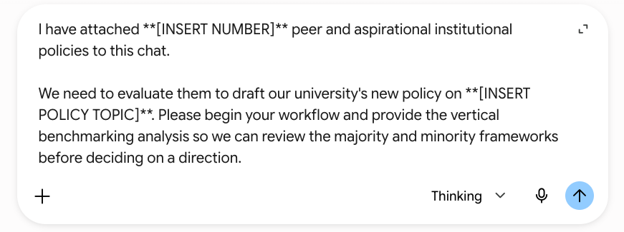

- Add the number of policies you’re uploading and the title of the policy you’re drafting. Also, identify whether you are uploading any regulatory excerpts (see Step 6 below for more details). Delete the placeholder sentence if it’s not applicable.

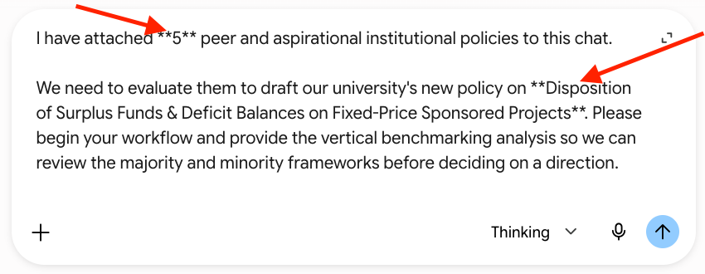

- Change your Assistant’s model to your most capable model (e.g., Thinking, Pro, High).

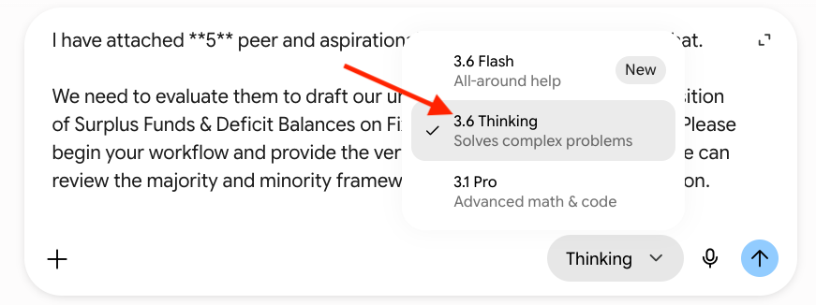

- Upload the peer and aspirational policies you would like to be analyzed and benchmarked. Ensure that the uploaded policies match the number you specified in the kick-off/starter prompt.

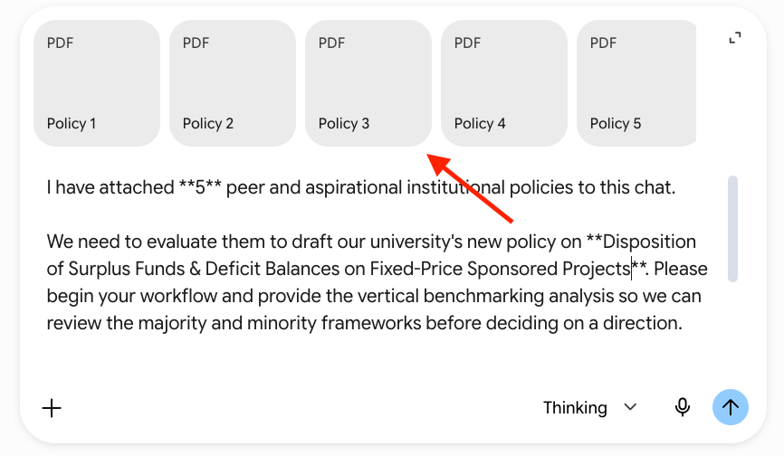

- Optional: Upload the most current versions of applicable regulations. Make sure to appropriately label the files and update the sentence at the end of the kick-off prompt to match the uploads.

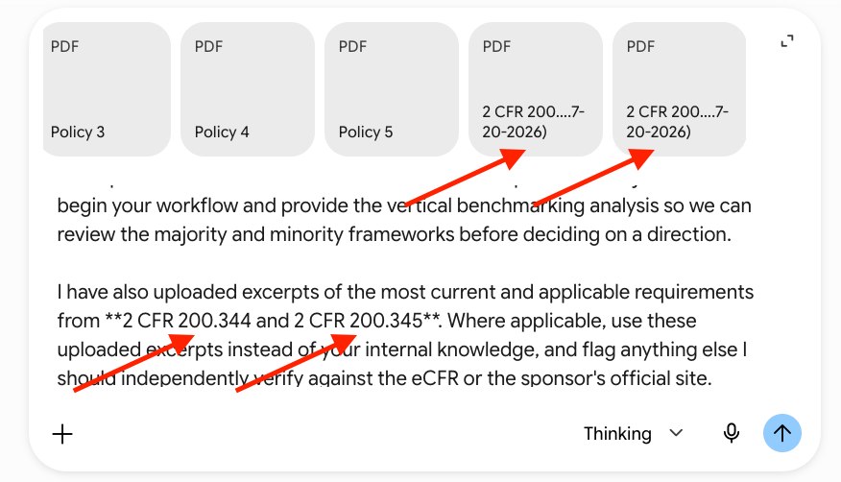

- Press “Enter/Return” on your keyboard or click “Submit” or similar on your Assistant’s chat interface.

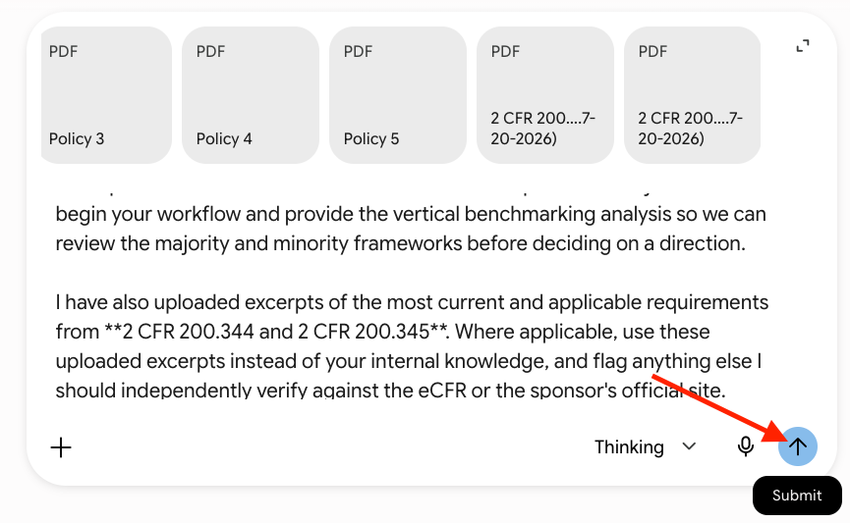

- Carefully review the “Step 1: Peer Benchmarking Analysis” output.

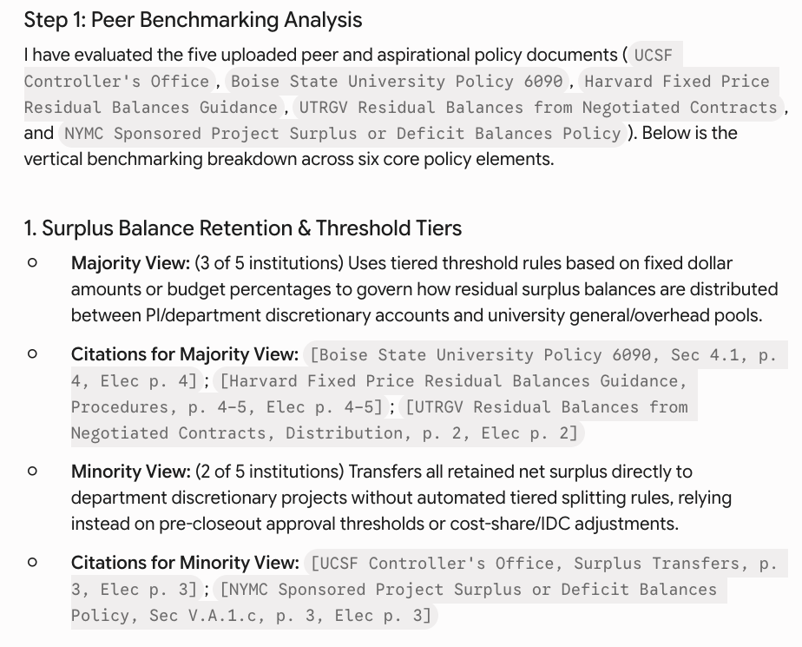

- Make decisions for the questions asked in “Step 2: Interactive Strategic Checkpoint (PAUSE).” These are critical for ensuring that a human user is in control.

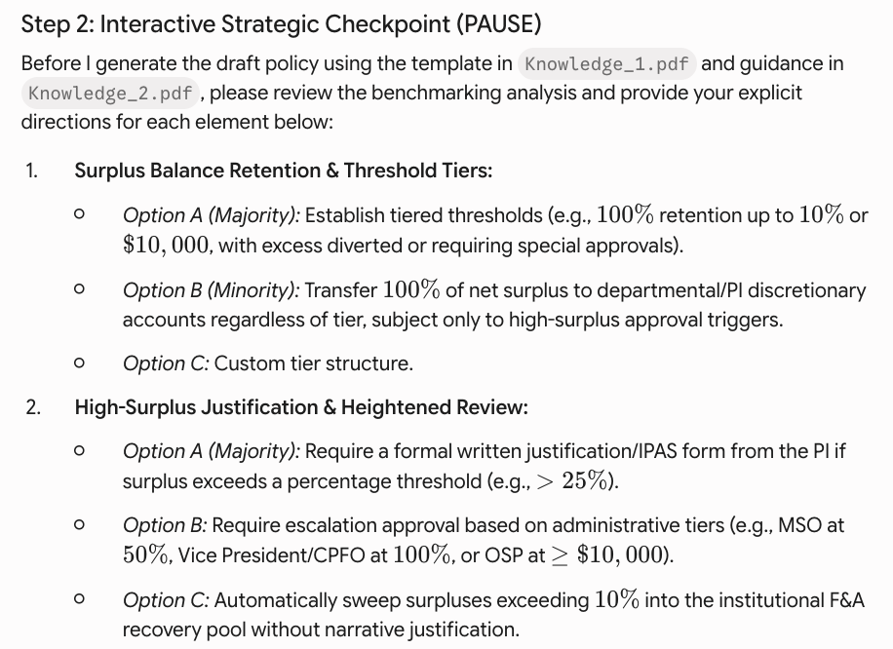

- Pay attention to any discussion in the “Regulatory Compliance Screen & Currency Warning” section, if any.

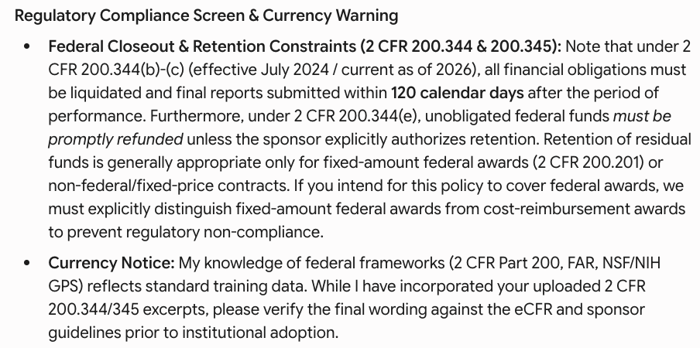

- Provide your answers to the questions in “Step 2: Interactive Strategic Checkpoint (PAUSE).”

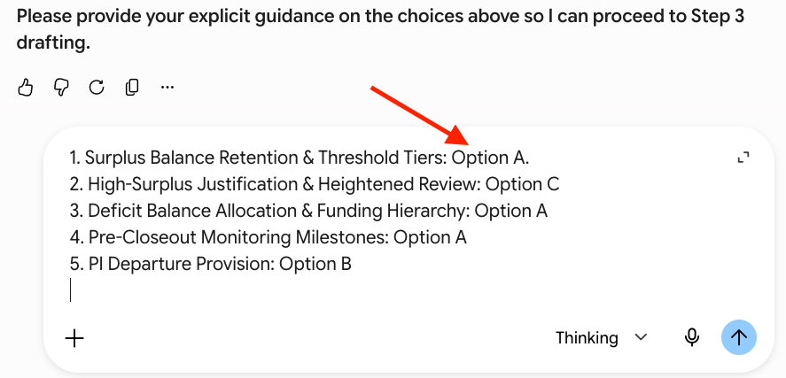

- Copy the generated (draft) policy from the code block and paste it into the document you will use to prepare the final policy.

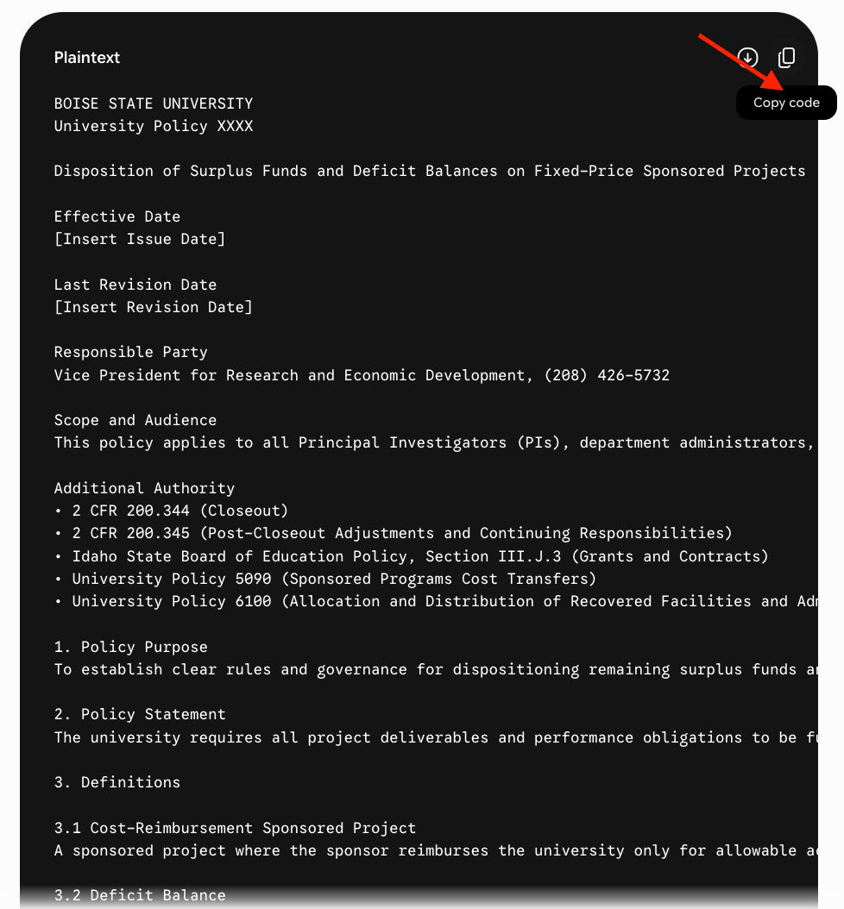

- Review the draft policy, make any desired revisions, and submit it through your appropriate approval channels.

- End instructions.

One-Time AI Agent Setup Instructions

Name

Copy and paste the following blue text into your AI agent’s name field:

Smith-Atlas Policy Evaluation & Drafting Assistant (SA-1007-V1)

Description

Copy and paste the following blue text into your AI agent’s description field (making sure to add a link to your user guide, which could be a revision of this document):

The Smith-Atlas Policy Evaluation & Drafting Assistant (SA-1007-V1) is a collaborative benchmarking and drafting Assistant designed for university research administrators. It analyzes peer and aspirational institution policies to identify majority and minority views, guides the user through strategic policy choices, and drafts compliance-aligned institutional policies using templates and style guides from the user’s institution. The user guide is available at [USER GUIDE URL].

Instructions

Copy and paste all of the text from the Loader.txt file into your Assistant’s Instructions field, exactly as written (including the formatting symbols, as they are part of the instructions).

Assistant Knowledge

  - Upload the Process.txt File to the Knowledge

    - Upload the Process.txt file into your Assistant’s internal “Knowledge.” Do not change the file name.

      - The “Knowledge” area is generally found following the “Instructions” area (i.e., where you paste the Loader.txt system prompt instructions).

  - Prepare and upload your additional files into the “Knowledge.” A policy template (i.e., shows the required/common elements your institution wants) is critical; a policy drafting guidance (i.e., guidance for writing to your audience and using plain language, gender-inclusive language, and the brand standards style guide) is helpful.

    - Label the files as “Knowledge_1.[extension],” “Knowledge_2.[extension],” etc.

    - Add a cover sheet as the first page of the attachment. The cover sheet should clearly state the document's role in machine-readable, consistent terms. LLMs anchor strongly on the first lines of a document, so a predictable label block there is more reliable than prose scattered through a cover page. The following blue text template is suggested:

KNOWLEDGE FILE ROLE: This document is the policy template that must be used for drafting the policy.
PURPOSE: Defines the required layout and section headers for the draft policy (Purpose, Scope, Definitions, etc.).
APPLY WHEN: This should be used when drafting the policy to ensure it has the correct format and sections.

    - Upload all of the files to the “Knowledge” area of your Assistant.

This should answer what this document is. This is not just a topic.
This should describe what the document governs.
This should describe when the assistant should use this document.

